EXPERIMENT 1: CONVERT AN IMAGE TO GRAYSCALE
AIM
To read an image using Python and convert the image from colour format to grayscale using OpenCV.
INPUT
Input: A colour image selected by the user.
OUTPUT
Output: The same image converted into grayscale.
ALGORITHM
1. Start the program.
2. Import the OpenCV library.
3. Read the input image using cv2.imread().
4. Convert the colour image to grayscale using cv2.cvtColor() with COLOR_BGR2GRAY.
5. Display the grayscale image.
6. Wait for a key press and close the image window.
7. Stop the program.
PROCEDURE
1. Open Python IDLE and create a new Python file.
2. Enter the program code and save the file with a suitable .py filename.
3. Run the program using F5.
4. Select the input image when the file-selection window appears.
5. Observe the processed output image.
6. Save/take a screenshot of the input and output images for the practical record.
PROGRAM / CODE
import cv2
from tkinter import Tk
from tkinter.filedialog import askopenfilename
root = Tk()
root.withdraw()
file = askopenfilename()
img = cv2.imread(file)
gray = cv2.cvtColor(img, cv2.COLOR_BGR2GRAY)
cv2.imshow("Gray Image", gray)
cv2.waitKey(0)
cv2.destroyAllWindows()
INPUT IMAGE
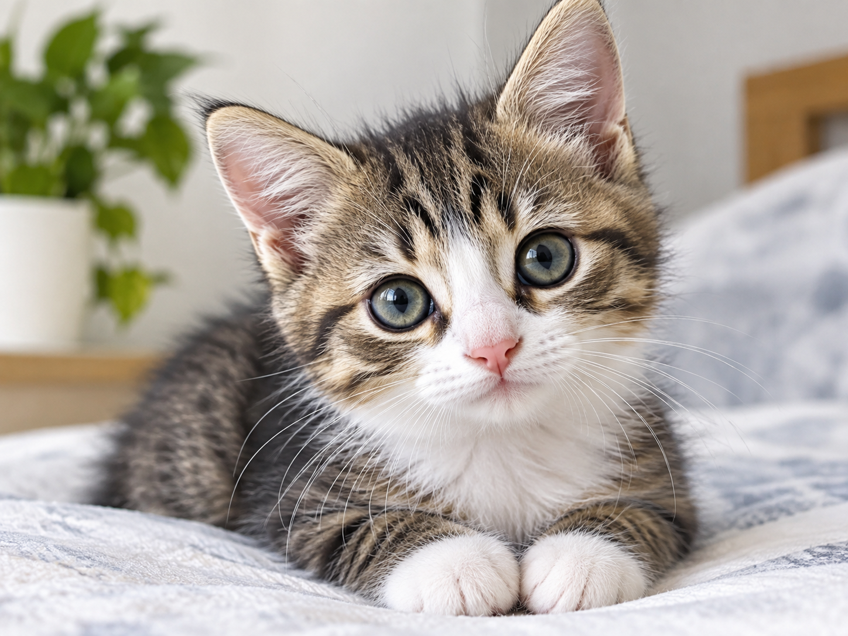

OUTPUT IMAGE
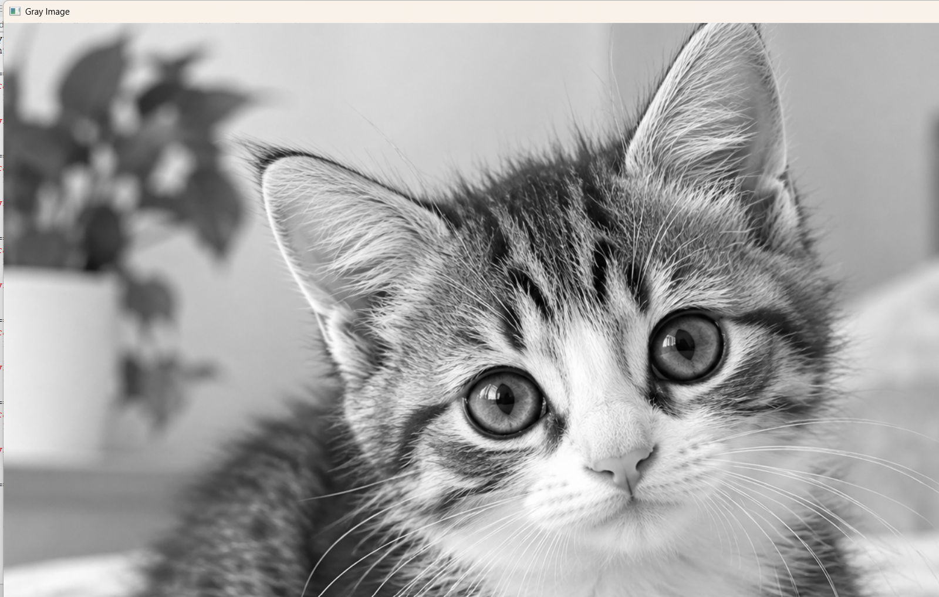

RESULT
Thus, the image processing operation was performed successfully and the required output was obtained.
EXPERIMENT 2: GAUSSIAN BLUR
AIM
To read an image using Python and reduce image noise by applying Gaussian Blur using OpenCV.
INPUT
Input: A colour image selected by the user.
OUTPUT
Output: A blurred version of the input image.
ALGORITHM
1. Start the program.
2. Import the OpenCV library.
3. Select and read the input image.
4. Apply Gaussian Blur using cv2.GaussianBlur().
5. Use a 5 × 5 kernel to blur the image.
6. Display the blurred image.
7. Wait for a key press and close the image window.
8. Stop the program.
PROCEDURE
1. Open Python IDLE and create a new Python file.
2. Enter the program code and save the file with a suitable .py filename.
3. Run the program using F5.
4. Select the input image when the file-selection window appears.
5. Observe the processed output image.
6. Save/take a screenshot of the input and output images for the practical record.
PROGRAM / CODE
import cv2
from tkinter import Tk
from tkinter.filedialog import askopenfilename
root = Tk()
root.withdraw()
file = askopenfilename()
img = cv2.imread(file)
blur = cv2.GaussianBlur(img, (5, 5), 0)
cv2.imshow("Blurred Image", blur)
cv2.waitKey(0)
cv2.destroyAllWindows()
INPUT IMAGE
OUTPUT IMAGE
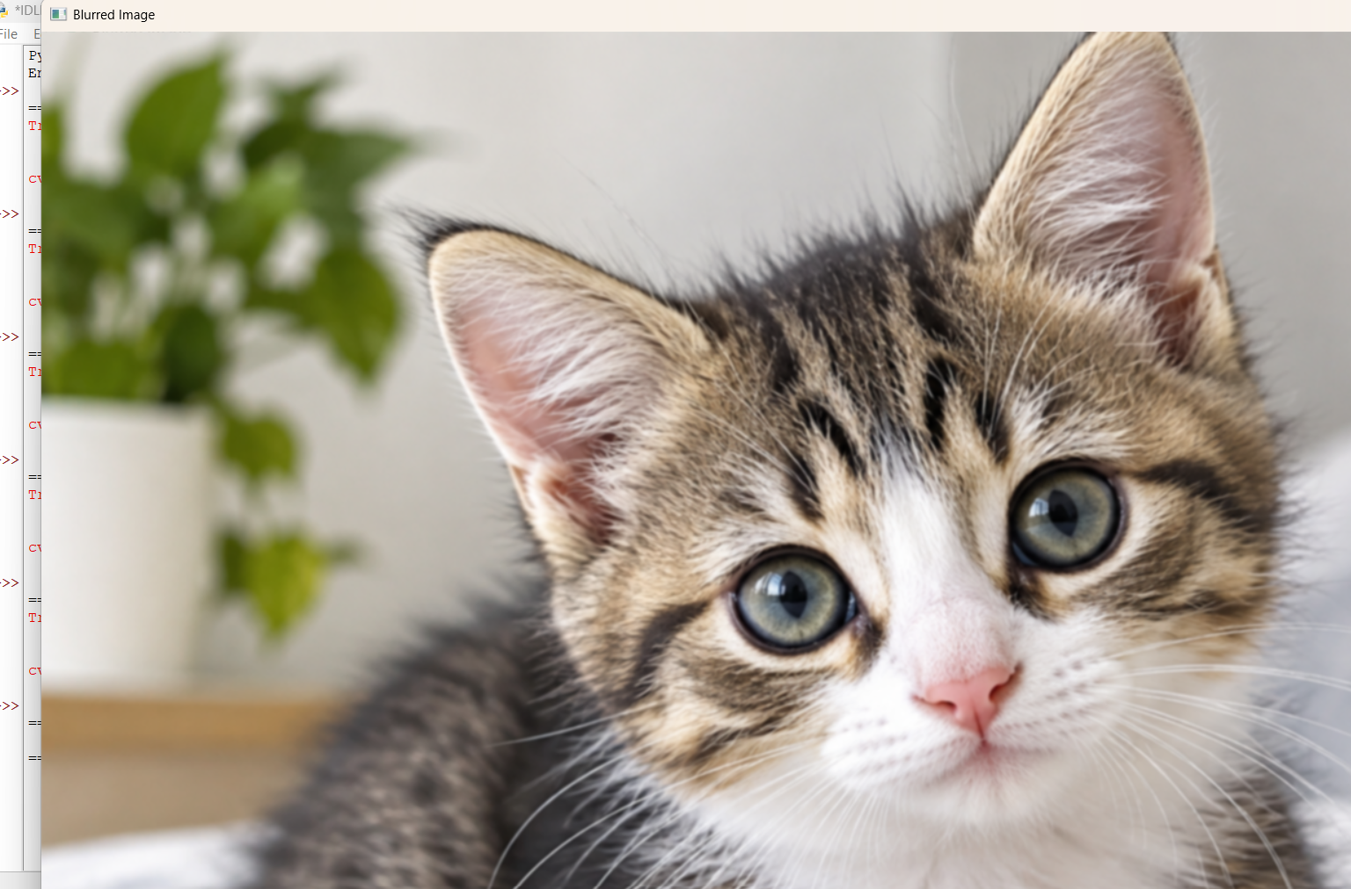

RESULT
Thus, the image processing operation was performed successfully and the required output was obtained.

EXPERIMENT 3: IMAGE OUTLINE USING CANNY
AIM
To read an image using Python and detect the outline or edges of objects using the Canny edge detection function.
INPUT
Input: A colour image selected by the user.
OUTPUT
Output: A black-and-white image showing the detected outlines/edges.
ALGORITHM
1. Start the program.
2. Import the OpenCV library.
3. Select and read the input image.
4. Convert the input image to grayscale.
5. Apply the Canny edge detection function with threshold values 100 and 200.
6. Display the detected edges or outline.
7. Wait for a key press and close the image window.
8. Stop the program.
PROCEDURE
1. Open Python IDLE and create a new Python file.
2. Enter the program code and save the file with a suitable .py filename.
3. Run the program using F5.
4. Select the input image when the file-selection window appears.
5. Observe the processed output image.
6. Save/take a screenshot of the input and output images for the practical record.
PROGRAM / CODE
import cv2
from tkinter import Tk
from tkinter.filedialog import askopenfilename
root = Tk()
root.withdraw()
file = askopenfilename()
img = cv2.imread(file)
gray = cv2.cvtColor(img, cv2.COLOR_BGR2GRAY)
edges = cv2.Canny(gray, 100, 200)
cv2.imshow("Outline", edges)
cv2.waitKey(0)
cv2.destroyAllWindows()
INPUT IMAGE

OUTPUT IMAGE
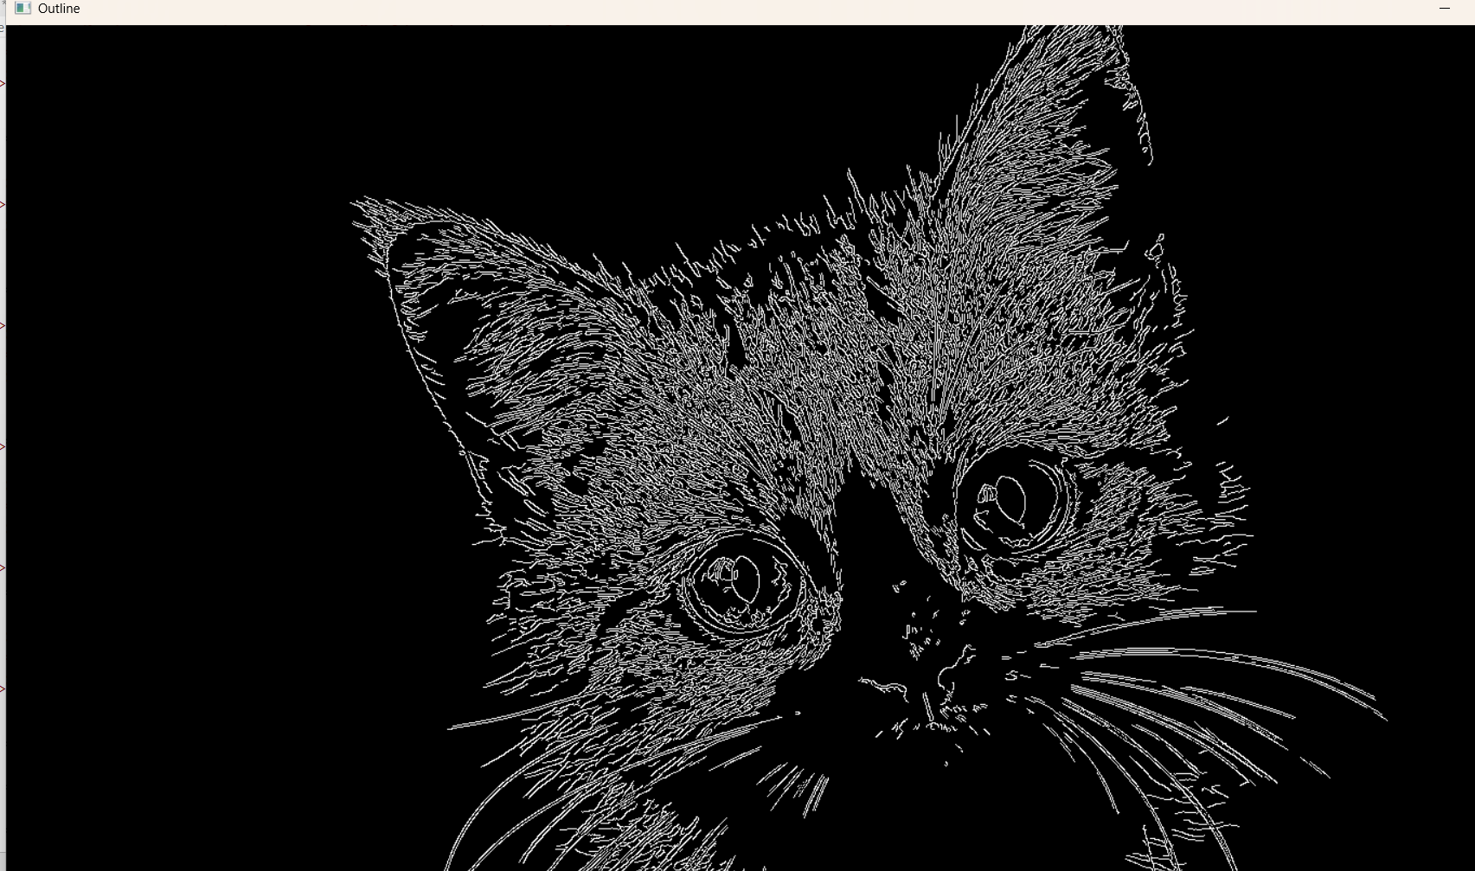

RESULT
Thus, the image processing operation was performed successfully and the required output was obtained.

